Dataset
rnd_room_c2_05: HEAD tilt: -0.4
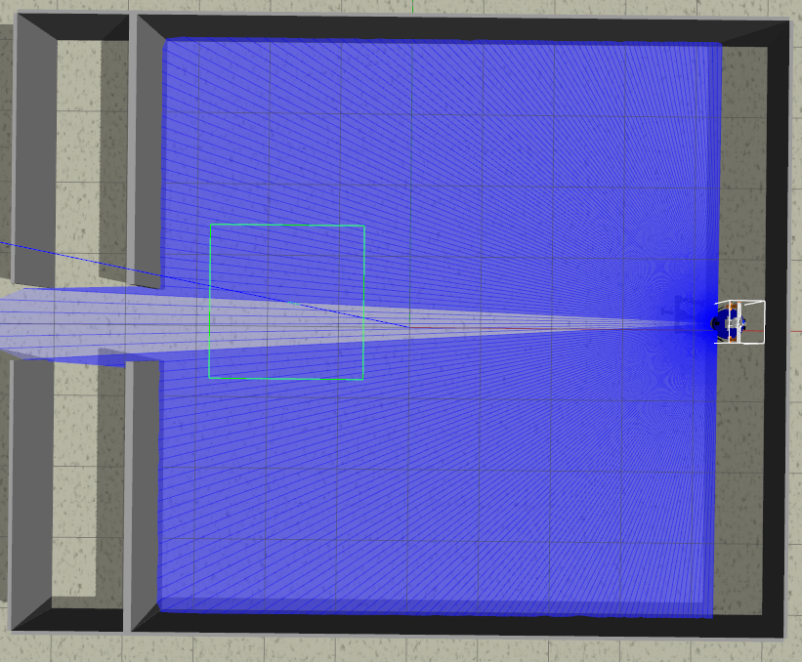
samples
1)
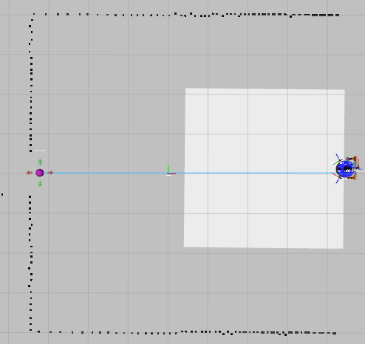
linea recta a puerta 2.3m (x3) (4.6 0.0 PI) to (-3.2, 0.0)
files: data_from_path_2025-02-27_10-14-27 to data_from_path_2025-02-27_10-15-26

2)
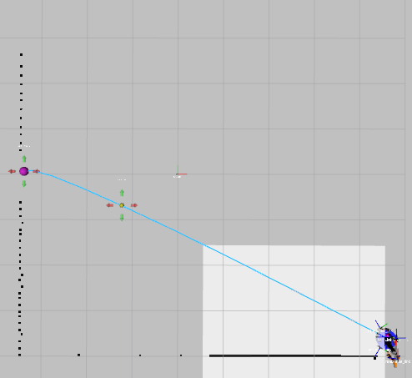
esq inf izq a puerta 8.7m (x3) (4.6 -3.6 PI) to (-3.2, 0.0)
files: data_from_path_2025-02-27_10-19-38 to data_from_path_2025-02-27_10-20-29

3)
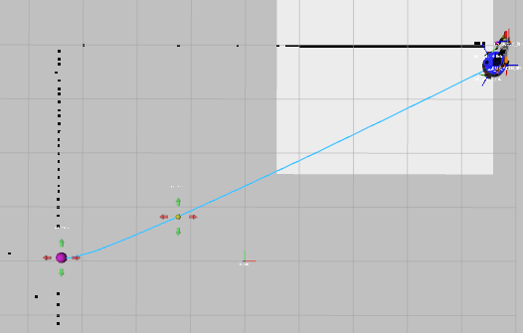
esq inf der a puerta 8.7m (x2) (4.6 3.6 PI) to (-3.2, 0.0)
files: data_from_path_2025-02-27_10-23-03 to data_from_path_2025-02-27_10-23-50

4)
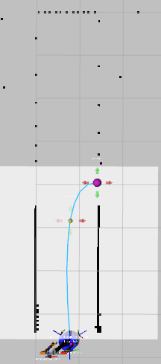
pasillo izq a puerta der 3.6m (x2) (-4.2 -3.6 1.57075) to (-3.6, 0.0)
files: data_from_path_2025-02-27_10-31-18 to data_from_path_2025-02-27_10-31-47

5)
pasillo izq a puerta der 3.6m (x2) (-4.2 -3.6 -1.57075) to (-3.6, 0.0)
files: data_from_path_2025-02-27_10-33-32 to data_from_path_2025-02-27_10-33-48
6)
pasillo izq a puerta der 3.6m (x2) (-4.2 -3.6 0) to (-3.6, 0.0)
files: data_from_path_2025-02-27_10-35-05 to data_from_path_2025-02-27_10-35-21

7)
pasillo izq a puerta der 3.6m (x2) (-4.2 -3.6 PI) to (-3.6, 0.0)
files: data_from_path_2025-02-27_10-36-05 to data_from_path_2025-02-27_10-36-41

8)
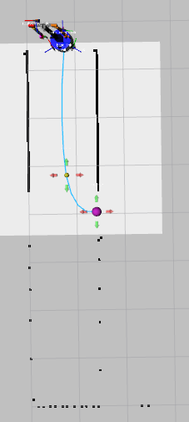
pasillo der a puerta izq 3.6m (x2) (-4.2 3.6 -1.57075) to (-3.6, 0.0)
files: data_from_path_2025-02-27_10-39-14 to data_from_path_2025-02-27_10-39-30

9)
pasillo der a puerta izq 3.6m (x2) (-4.2 3.6 1.57075) to (-3.6, 0.0)
files: data_from_path_2025-02-27_10-40-33 to data_from_path_2025-02-27_10-40-49

10)
pasillo der a puerta izq 3.6m (x2) (-4.2 3.6 0) to (-3.6, 0.0)
files: data_from_path_2025-02-27_10-41-31 to data_from_path_2025-02-27_10-41-56

11)
pasillo der a puerta izq 3.6m (x2) (-4.2 3.6 PI) to (-3.6, 0.0)
files: data_from_path_2025-02-27_10-42-31 to data_from_path_2025-02-27_10-42-50

12)
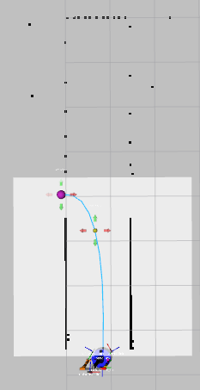
pasillo izq a puerta izq 3.7m (x2) (-4.2 -3.6 1.57075) to (-5.1, 0.0)
files: data_from_path_2025-02-27_10-48-10 to data_from_path_2025-02-27_10-48-27

13)
pasillo izq a puerta izq 3.7m (x2) (-4.2 -3.6 -1.57075) to (-5.1, 0.0)
files: data_from_path_2025-02-27_10-49-12 to data_from_path_2025-02-27_10-49-29

14)
pasillo izq a puerta izq 3.7m (x2) (-4.2 -3.6 0) to (-5.1, 0.0)
files: data_from_path_2025-02-27_10-50-30 to data_from_path_2025-02-27_10-50-48

15)
pasillo izq a puerta izq 3.7m (x2) (-4.2 -3.6 PI) to (-5.1, 0.0)
files: data_from_path_2025-02-27_10-51-39 to data_from_path_2025-02-27_10-52-19

16)
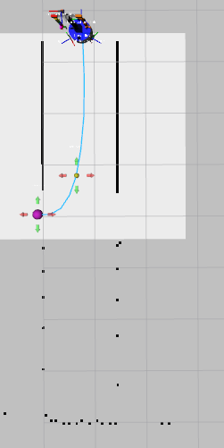
pasillo der a puerta der 3.6m (x2) (-4.2 3.6 -1.57075) to (-5.1, 0.0)
files: data_from_path_2025-02-27_10-54-44 to

17)
pasillo der a puerta der 3.6m (x2) (-4.2 3.6 1.57075) to (-5.1, 0.0)
files: data_from_path_2025-02-27_10-55-50 to data_from_path_2025-02-27_10-56-06

18)
pasillo der a puerta der 3.6m (x2) (-4.2 3.6 0) to (-5.1, 0.0)
files: data_from_path_2025-02-27_10-56-35 to data_from_path_2025-02-27_10-56-54

19)
pasillo der a puerta der 3.6m (x2) (-4.2 3.6 PI) to (-5.1, 0.0)
files: data_from_path_2025-02-27_10-57-29 to data_from_path_2025-02-27_10-57-48

20)
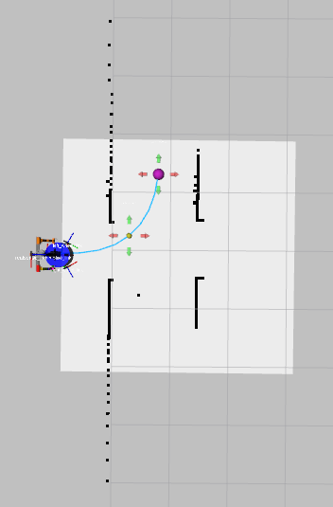
entrada a pasillo izq 2.2m (x4) (-6.0 0.0 0) to (-4.2, 1.3)
files: data_from_path_2025-02-27_11-03-13 to data_from_path_2025-02-27_11-03-13

21)
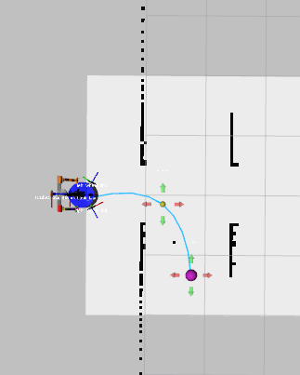
entrada a pasillo der 2.2m (x4) (-6.0 0.0 0) to (-4.2, -1.3)
files: data_from_path_2025-02-27_11-06-54 to data_from_path_2025-02-27_11-07-39

22)
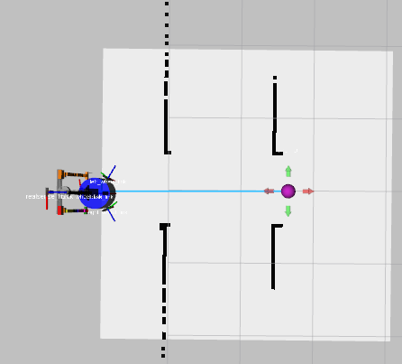
entrada puerta a puerta 2.6m (x4) (-6.0 0.0 0) to (-3.3, 0.0)
files: data_from_path_2025-02-27_11-10-22 to data_from_path_2025-02-27_11-11-00
-----
NO Mirror
-----

